ID: 25CE085

Aim: To initiate the StudentHub Portal project by analyzing requirements, identifying user roles and key modules, creating a sitemap and low-fidelity wireframe, and setting up a structured GitHub repository.

Tools/Technology to be Used:
VS Code – To create and manage HTML files
Draw. io – To create sitemap and wireframe
Git – For version control
GitHub – To store and manage the project repository
HTML – To design the web pages

Theory Logic: Core concept of Practical
Requirement Analysis is the process of identifying the needs, features, users, and scope of a web application before development.
For the StudentHub Portal, the main users are Students, Faculty, and Admin. The portal contains multiple modules such as Home, About, Registration, Login, Dashboard, Profile, Events, Contact, FAQ, Feedback, etc.
A Sitemap represents the hierarchical structure and navigation flow of all web pages.
A Wireframe is a basic visual representation of a webpage that shows the placement of elements such as headings, menus, buttons, forms, and content.
Git and GitHub are used for version control and maintaining different versions of the project. After completing each practical, changes can be committed and pushed to GitHub.

Output: Screenshot only
Wireframe
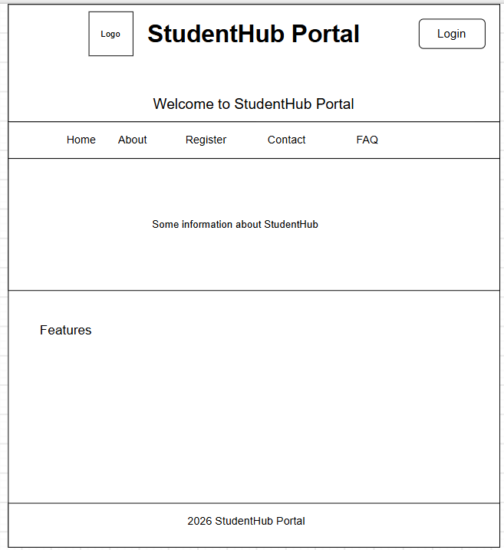
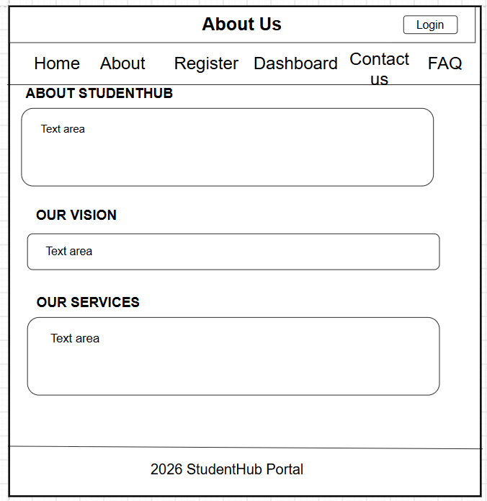
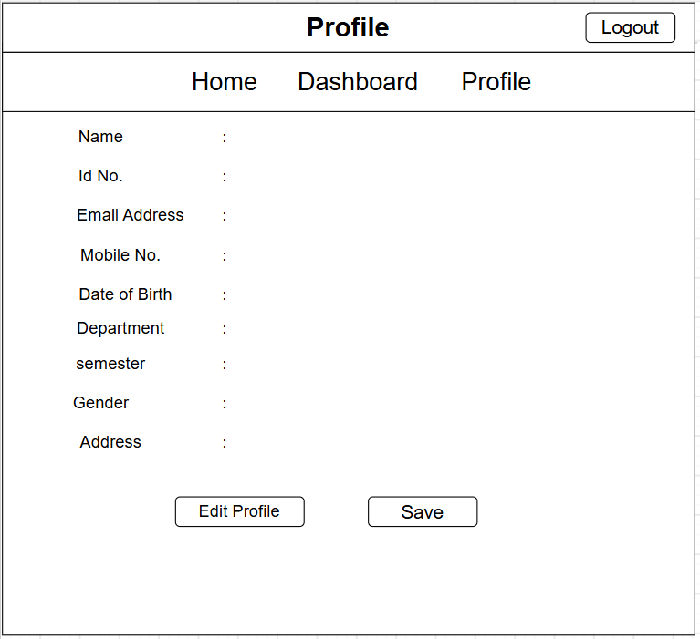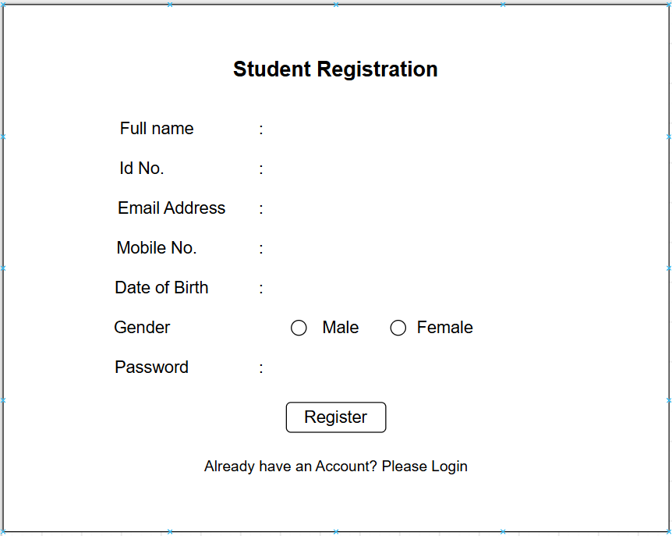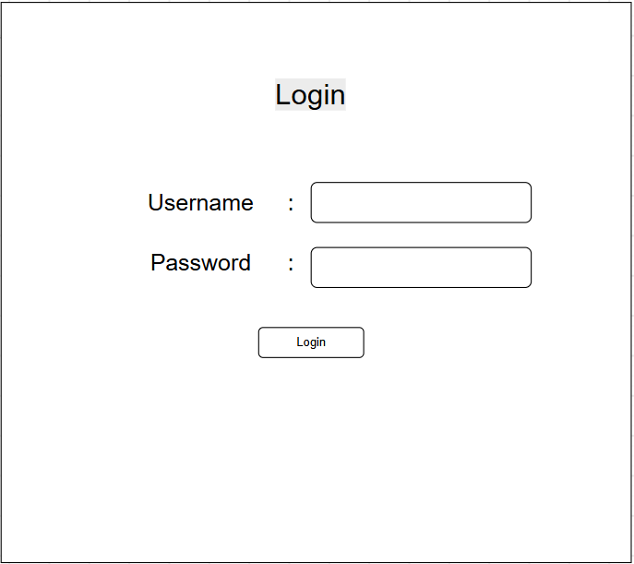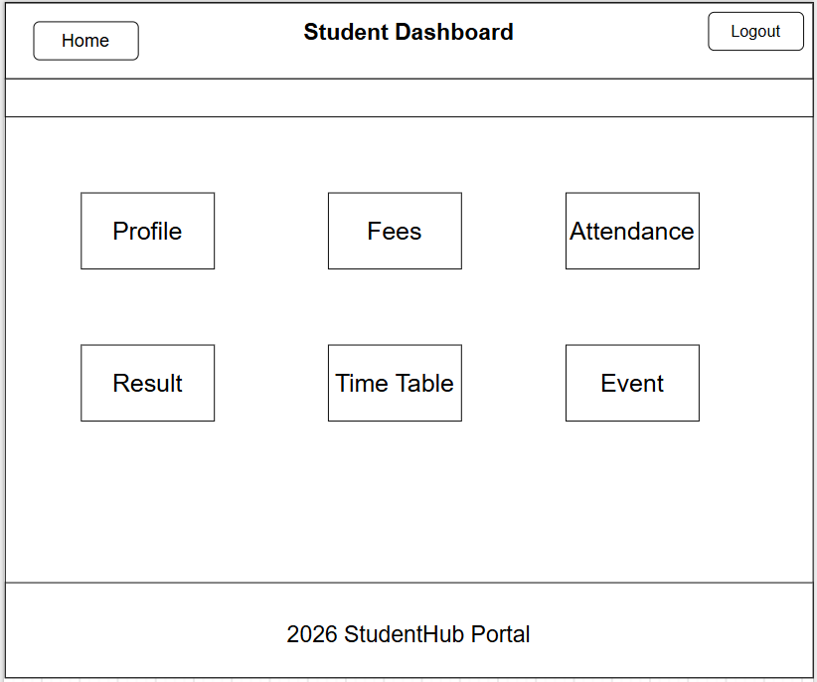
Sitemap
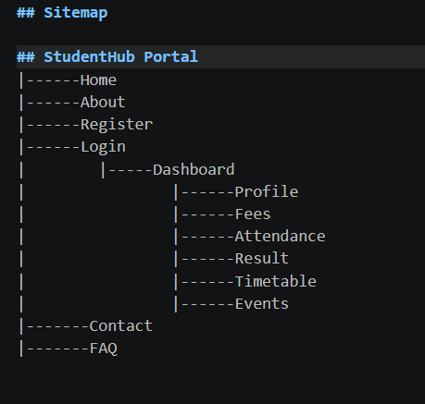
Requirements
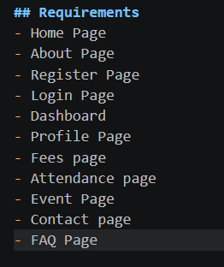

Question-Answer: As per given in Practical list. Write answer of each questions.

1. What is URL and parts of URL?
URL stands for Uniform Resource Locator. It is the address used to locate a resource such as a webpage on the Internet.

2. How does HTML file process in web browser?
When a user opens an HTML file, the browser reads and parses the HTML code. It creates a DOM (Document Object Model) from the HTML elements and then renders the page on the screen.

3. How will page navigation flow be managed among all HTML pages?
Page navigation will be managed using HTML anchor (<a>) tags. Each page will contain navigation links pointing to other HTML pages.

4. How will GitHub commits be maintained after each practical?
After completing each practical, the changes will be saved using Git and committed with a meaningful commit message. The commit will then be pushed to the GitHub repository.
This helps maintain the project's history and track changes made after every practical.

Conclusion:
I learned how to analyze project requirements, identify user roles and modules, design a sitemap and wireframe, organize a project folder structure, and create a GitHub repository. I also learned the importance of Git commits for maintaining project versions and tracking development progress.

